Collection Frameworks in Java

The reason collect frameworks is used to to reduce the time required to MAKE THE ENTIRE data structure from SCRATCH.

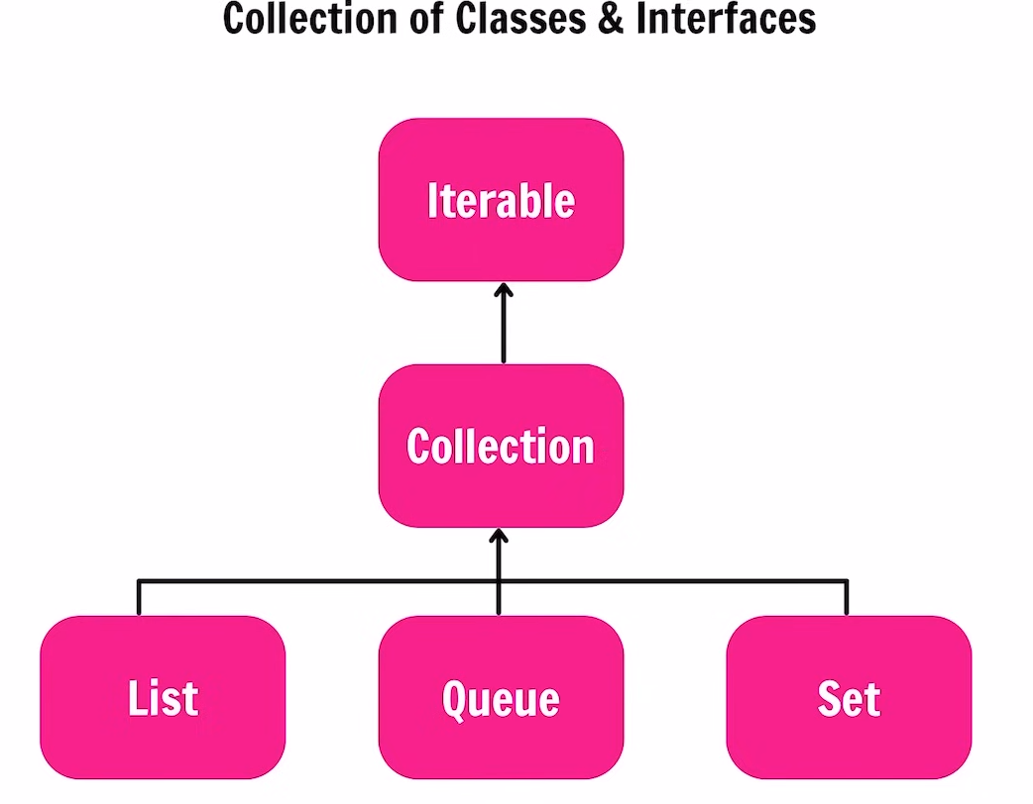



List Interface.
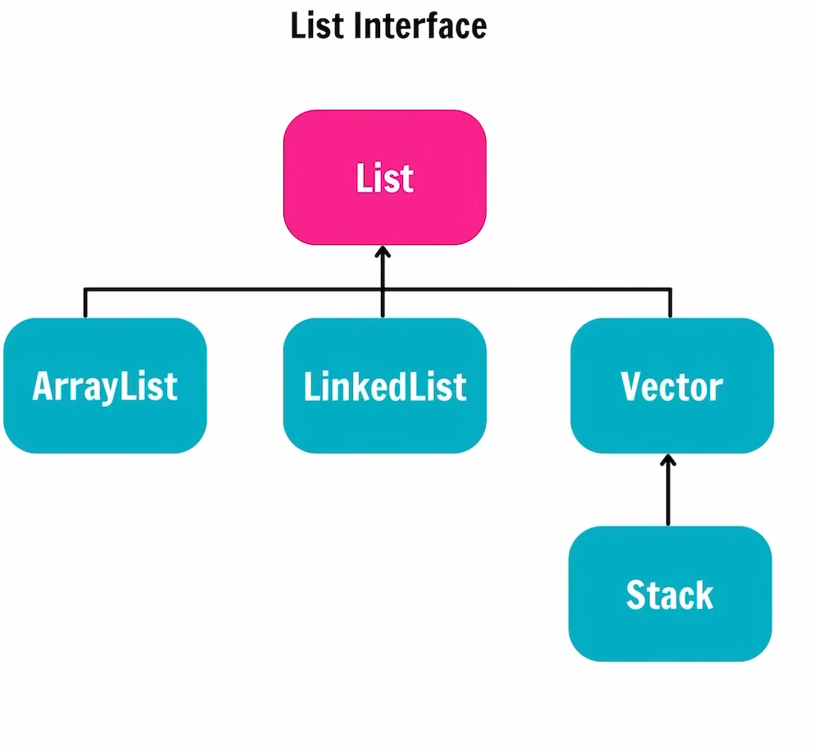
Queue Interface
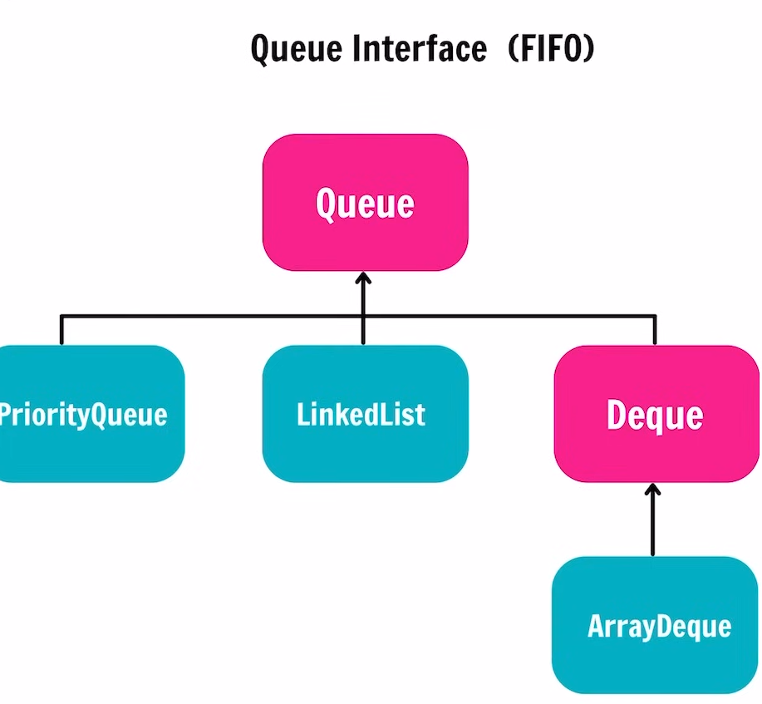

Set Interface: -
Unique object
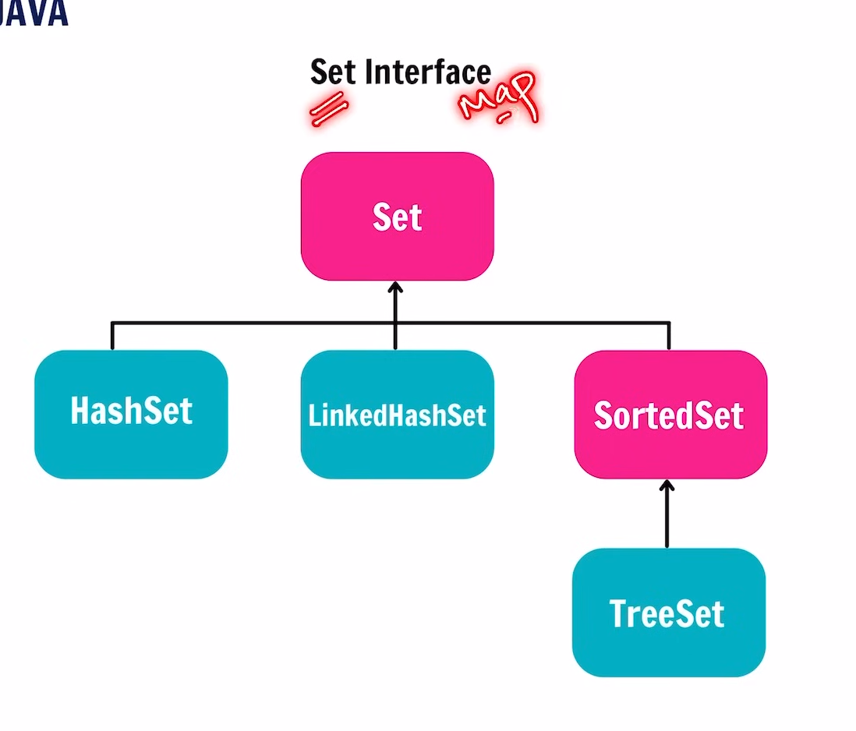
Map Interface:-
Key-Value pair
